Anti-Repost Tool for Cosplay Photos
S-11 Changing signing information, remaking, authorizations and joint rights, corrected versions
Edition 1 (Draft) 2026-09-29 · Ishikawa Sou
Nagareyama Software Development Co., Ltd. (NRSD)
© 2026 Nagareyama Software Development Co., Ltd. (NRSD), Lead Developer: Ishikawa Sou (石川宗). Copyright in this document belongs to Nagareyama Software Development Co., Ltd. (NRSD). Rights in the third-party standards, software, commentaries on laws, and other materials referred to in this document belong to their respective holders. This is a translation of the Japanese original; where they differ, the Japanese original prevails.
Contents
S-11a Changing signing information (G-19)
S-11b Remaking the personal root (20 years, loss, suspected leak)
S-11c Authorizations and joint rights (G-18), corrected Enclosed Documents
Gaps (found later and fixed)

Origin: Chapter 2, 3.4, 3.6, 5.1–5.4, 6, and 7.2; Chapter 5, 2.4; Chapter 10, G-18 and G-19; the corrections of Chapter 3, 10.2.

S-11a Changing signing information (G-19)
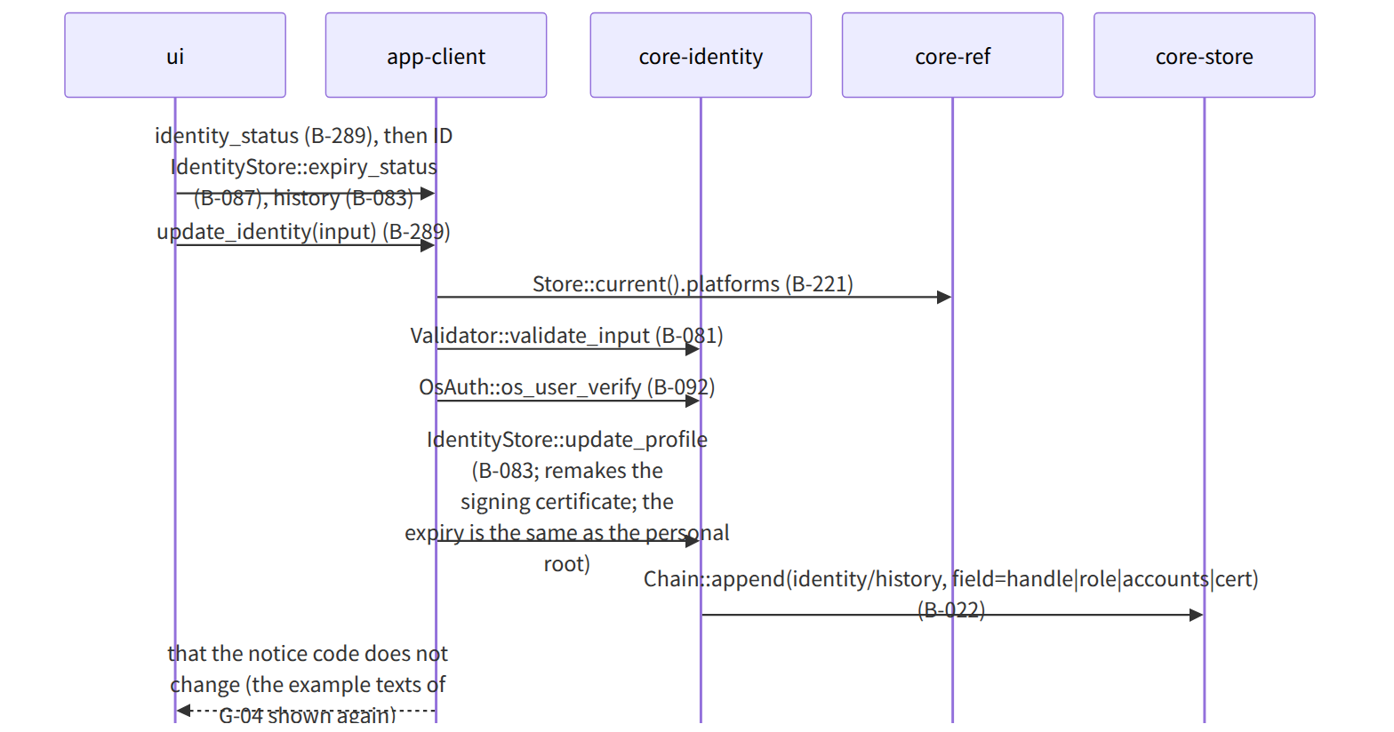
Figure：S-11a Changing signing information (G-19)

S-11b Remaking the personal root (20 years, loss, suspected leak)
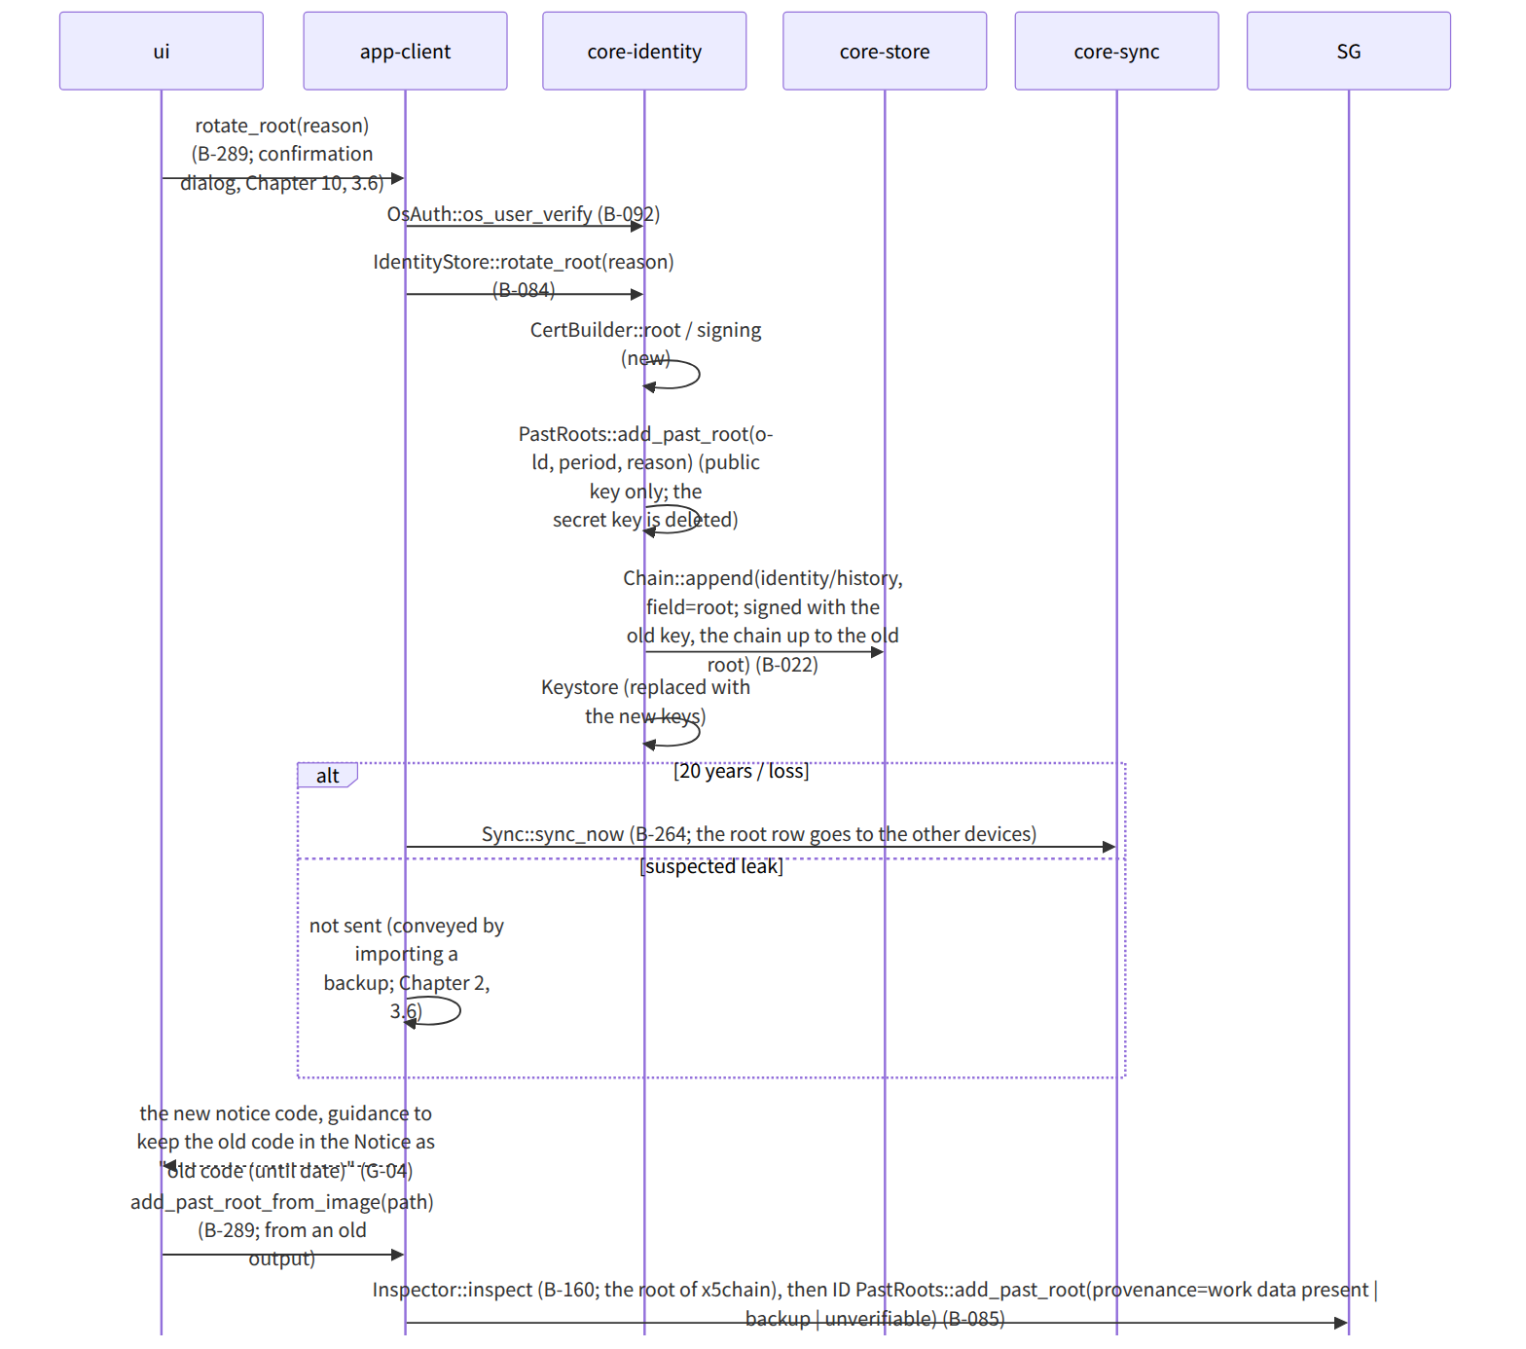
Figure：S-11b Remaking the personal root (20 years, loss, suspected leak)

S-11c Authorizations and joint rights (G-18), corrected Enclosed Documents
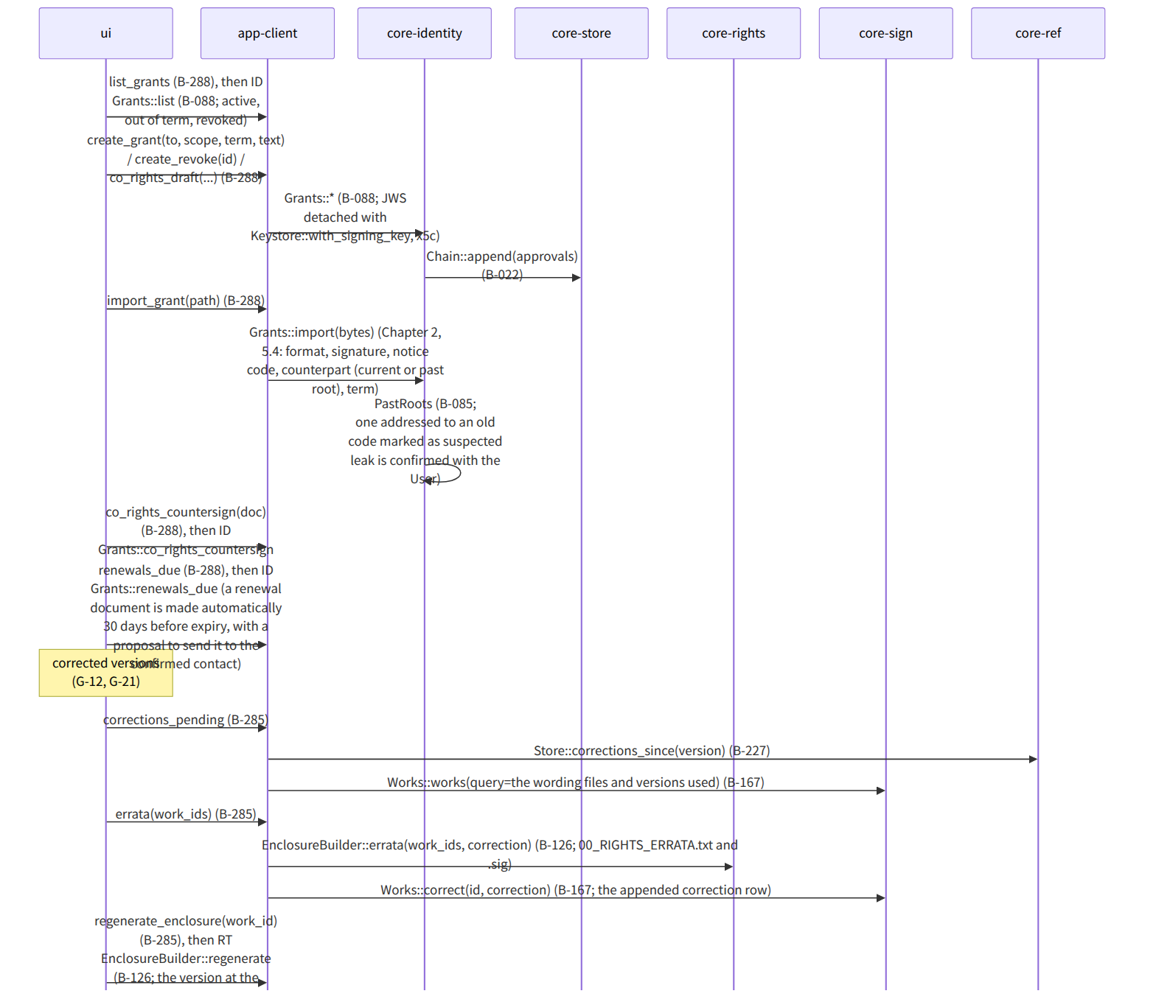
Figure：S-11c Authorizations and joint rights (G-18), corrected Enclosed Documents

Gaps (found later and fixed)
- The index for looking up Works::works(query) by “the SHA-256 of the wording files used” was not in core-sign's data design (it is in the rights field of the work data), so lookup_by_text_hash(sha256) was added to WorkIndex (core-store B-029) (core-store.md).
- The trigger for “automatically making” the renewal document of an authorization (renews) (Chapter 2, 5.1) was not in the background queue, so Grants::renewals_due is run on the same tick as S-07f and the documents made are shown in G-21 (“proposal to renew authorizations (Chapter 2, 5.1)” was added to “deadline notices” at the end of the background order in Chapter 1, 7).

